**Project 6: Computer Architecture**

**Background**

In previous projects we've built the computer's basic *processing* and *storage* devices (*ALU* and *RAM*, respectively). In this project we will put everything together, yielding the complete *Hack Hardware Platform*. The result will be a general-purpose computer that can run any program that you fancy.

**Objective**

Complete the construction of the Hack CPU and computer platform, leading up to the top-most Computer chip.

**Chips**

|  |  |  |
| --- | --- | --- |
| Chip (HDL) | Description | Testing |
| Memory.hdl | Entire RAM address space | Test this chip using Memory.tst and Memory.cmp |
| CPU.hdl | The Hack CPU | Recommended test files: CPU.tst and CPU.cmp.  Alternative test files (less thorough but do not require using the built-in DRegister): CPU-external.tst and CPU-external.cmp. |
| Computer.hdl | The platform's top-most chip | Test by running some Hack programs on the constructed chip. See more instructions below. |

**Contract**

The computer platform that you build should be capable of executing programs written in the *Hack machine language*, specified in Chapter 4. Demonstrate this capability by having your Computer chip run the three test programs given below.

**Testing**

**Testing the Memory and CPU chips:** It's important to unit-test these chips before proceeding to build the overall Computer chip. Use the the test scripts and compare files listed above.

**Testing the Computer chip:** A natural way to test the overall Computer chip implementation is to have it execute some sample programs written in the Hack machine language. In order to perform such a test, one can write a test script that (i) loads the Computer.hdl chip description into the supplied *Hardware Simulator*, (ii) loads a machine-level program from an external .hack file into the ROM chip-part of the loaded Computer.hdl chip, and then (iii) runs the clock enough cycles to execute the loaded instructions. We supply all the files necessary to run three such tests, as follows:

|  |  |
| --- | --- |
| Program | Comments |
| Add.hack | Adds up the two constants 2 and 3 and writes the result in RAM[0]. Recommended test:ComputerAdd.tst and ComputerAdd.cmp. Alternative test (less thorough but only requires usage of the built-in RAM16K): ComputerAdd-external.tst and ComputerAdd-external.cmp. |
| Max.hack | Computes the maximum of RAM[0] and RAM[1] and writes the result in RAM[2]. Recommended test:ComputerMax.tst and ComputerMax.cmp. Alternative test (less thorough but only requires usage of the built-in RAM16K): ComputerMax-external.tst and ComputerMax-external.cmp. |
| Rect.hack | Draws a rectangle of width 16 pixels and length RAM[0] at the top left of the screen. Recommended test ComputerRect.tst and ComputerRect.cmp. Alternative test (less thorough but does not require usage of any built-in chips): ComputerRect-external.tst and ComputerRect-external.cmp. |

Before testing your Computer chip on any one of the above programs, read the relevant .tst file and be sure to understand the instructions given to the simulator. Appendix B of the book may be a useful reference here.

**Resources**

The relevant reading for this project are [Chapter 5](http://nand2tetris.org/chapters/chapter%2005.pdf), [Appendix A](http://nand2tetris.org/chapters/appendix%20A.pdf), and [Appendix B](http://nand2tetris.org/chapters/appendix%20B.pdf) (as a reference). Specifically, all the chips described in Chapter 5 should be implemented in the *Hardware Description Language* (HDL) specified in Appendix A.

The resources that you need for this project are the supplied *Hardware Simulator* and the files listed above.

**Implementation Tips**

Complete the computer's construction in the following order:

**Memory:** This chip includes three chip-parts: RAM16K, Screen, and Keyboard. The Screen and the Keyboard are available as built-in chips, and thus there is no need to implement them. Although the RAM16K chip was built in Project 3, we recommend using its built-in version, as it provides a debugging-friendly GUI.

**CPU:** This chip can be constructed according to the proposed CPU implementation given in Figure 5.9 of Chapter 5, using the ALU and register chips built in Projects 2 and 3, respectively. We recommend though using built-in chip-parts instead, in particular ARegister and DRegister. The built-in versions of these two chips have exactly the same interface and functionality as those of the Register chip specified in Chapter 3; however, they feature GUI side-effects that come handy for testing purposes.

In principle, your CPU implementation may include internal chips of your own specification, i.e. chips not mentioned in Figure 5.9 of Chapter 5. However, this is not recommended, and will most likely yield a less efficient CPU design. If you choose to create new chips not mentioned in the book, be sure to document and unit-test them carefully before you plug them into the architecture.

**Instruction memory:** Use the built-in ROM32K chip.

**Computer:** The top-most Computer chip can be constructed according to the proposed implementation shown in Figure 5.10 of Chapter 5.

**Tools**

All the chips mentioned in this project, including the topmost Computer chip, can be implemented and tested using the supplied *Hardware Simulator*. Here is a screen shot of testing the Rect.hack program on a Computer chip implementation.

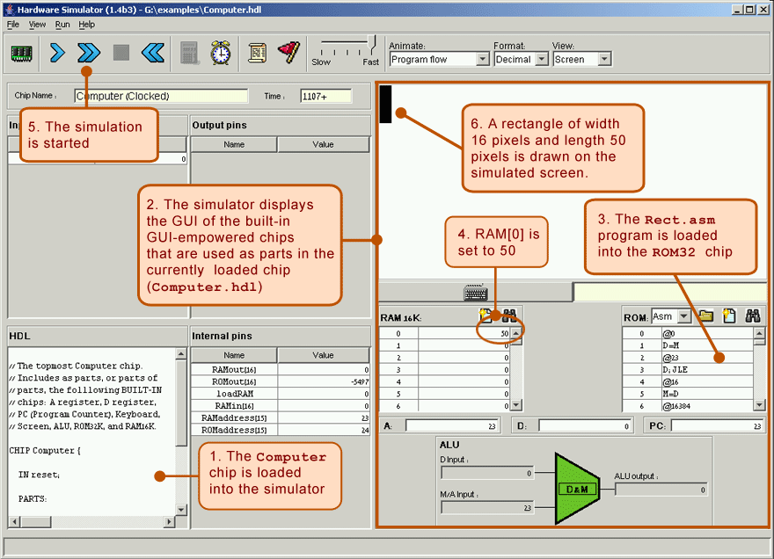

The Rect program illustrated above draws a rectangle of width 16 pixels and length RAM[0] at the top-left of the screen. Now here is an interesting observation: normally, when you run a program on some computer, and you don't get the desired result, you conclude that the program is buggy. In our case though, the supplied Rect program is *bug-free*. Thus, if running this program yields unexpected results, it means that the computer platform on which it runs (Computer.hdl and/or some of its lower-level chip parts) is buggy. If that is the case, you have to debug your chips.

**Rubric(50 Points):**

**Your turned in files will be graded based on the following tests:**

**CPU.tst: 13**

**Memory.tst: 9**

**CPU-external: 4**

**ComputerAdd: 4**

**ComputerAdd-external: 4**

**ComputerMax: 4**

**ComputerMax-external: 4**

**ComputerRect: 4**

**ComputerRect-external: 4**

**Make sure you did the tests on each of them.**

**What to turn-in**

Similar to what you submitted for Project one, turn in a zip file in format “FirstName-LastName-UIN” containing the three HDL files.